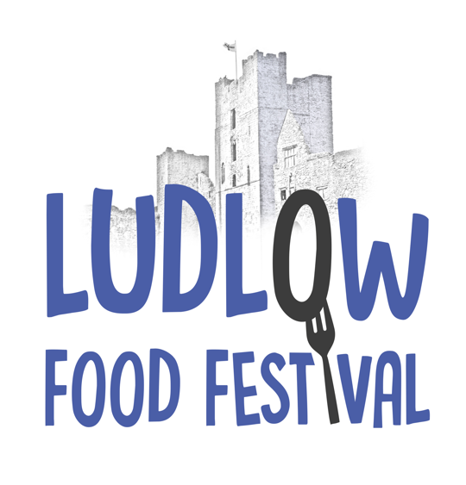
Ludlow Marches Food & Drink Festival
Unit 12, The Business Quarter
Eco Park Road
Ludlow
Shropshire SY8 1FD
Tel: 01584 873957
Email: LFFVolunteers@outlook.com
Web: www.foodfestival.co.uk
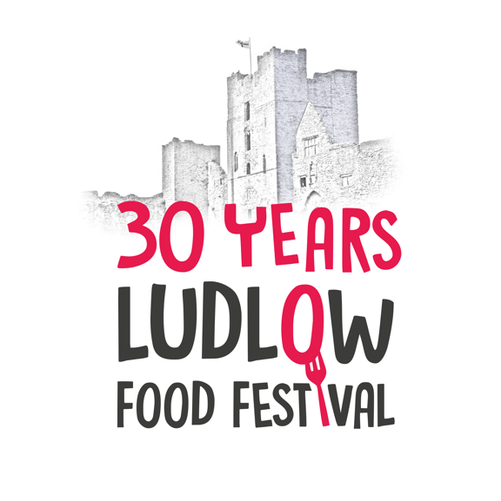
STUDENT VOLUNTEER REGISTRATION FORM – 2024
(Please complete and return to the above address or email, thank you!)

CONTACT DETAILS
Name:

Address:

Post Code:
Tel: (Day) (Evening)
Mobile
Email address:

Date of birth
Preferred method of contact (please tick √) Email [ ] Post [ ]

Please tell us when you are available and willing to work

The Festival in the castle is open to the public at the following times:
- Friday 13th September 10.00am to 5.00pm
- Saturday 14th September 10.00am to 6.30pm
- Sunday 15th September 10.00am to 5.00pm

We also need volunteers to help with setting up and breaking down on:
Wednesday 11th and Thursday 12th September before opening to the public, and again breaking down and tidying up on the Monday 16th September.

I am ABLE to work for [ ] half-day sessions
(Please fill in here how many you are willing to work in total!)

Shifts will usually be Morning 9.15am to 1.30pm, Afternoon 12.30pm to 5.00pm – these times may have to be altered for some tasks and some areas may start at 8.00am and finish later than 5.30pm
PLEASE NOTE: the shifts overlap slightly to take the pressure off the exchange timings!

Please only tick the sessions where you are willing and able to undertake:

[ ] Wednesday afternoon [ ] Thursday morning [ ] Thursday afternoon

[ ] Friday morning [ ] Friday afternoon [ ] Saturday morning

[ ] Saturday afternoon until 6.30pm [ ] Sunday morning

[ ] Sunday afternoon until 7pm [ ] Monday morning [ ] Monday afternoon

Have you worked for us before? YES /NO
Have you used a till in previous work experience? YES / NO

Any other skills you feel would be beneficial to the role?

The general guidelines that MUST be adhered to are as follows:

- Please note that you may not be allocated ALL of the sessions you request as we are over subscribed for many of the sessions.

- Each shift will be 4 hours long – eg, if you start at 9am your first 20-minute break will be at 1pm. ONLY those students working the full day will be paid whilst taking their breaks. Refreshments will be available in the volunteer’s hospitality area and are free throughout the weekend. All students MUST arrive for duty at least 15 mins prior to their allocated start time.

- Duties can be varied and may involve collecting litter, cleaning tables, stamping hands, general stewarding, box breaking, staffing car parks and many many more numerous jobs, all of which are totally necessary in order to keep the Festival running smoothly.

- Clothes should be comfortable, clean and respectful – no slogans on t-shirts please!

- Mobile Devices – the use of mobile phones/devices are not permitted whilst you are on duty.

- It is most important that all visitors are ‘welcomed’ with a smile and so it is essential that you are prepared to be amenable and have a polite and friendly attitude to all to be part of the team.

- ALL students who are accepted as part of the Ludlow Food Festival Volunteer Team MUST be able to attend a ‘briefing’ session before their first shift – these will take place on site in the castle grounds, and you will be notified of the date and times in your allocation letter.
- The minimum wage, suitable for your age, will be paid in the week following the festival direct into your account on completion of a timesheet and bank details.

Special requests, comments or notes:

Your health, local knowledge and special skills

We are delighted to have your help, but do not wish to risk your health. If you have a medical condition that prevents you from undertaking certain tasks, please let us know - any information given will be treated in the strictest of confidence.

Do you have sufficient local knowledge to be able to direct visitors around Ludlow?
(eg cash machines, toilets, post office, named shops, pubs, etc) - YES / NO

If you have any special skills that may be useful, eg IT, languages, secretarial skills, or may be available to help out in the office, etc periodically during the lead up weeks to the festival, please let us know here:

Signature: Date:

I agree to follow the guidelines shown above while working at the Ludlow Marches Food & Drink Festival

GDPR
We will only store your information for as long as it necessary in relation to this year’s Festival. We will never share your information with any third party. Please visit our website to view our Privacy Policy; alternatively, please request a copy.

Ludlow Marches Food and Drink Festival
A company limited by guarantee. Registered in England and Wales no. 4230963. VAT reg. no. 783 6218 07
Registered office: dhjh, 81 Teme Street, Tenbury Wells, Worcestershire WR15 8AE
Ludlow Marches Food and Drink Festival is operated on a not-for-profit basis www.foodfestival.co.uk

